3.1 Functions of Two or More Variables Worksheet

- For each of the following functions state the domain & range in set notation and create a picture of the domain in the xy-plane.
- .

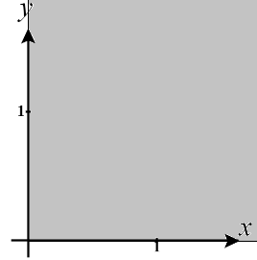
We see that and in order for this function to be defined. Therefore, we define the domain as: . A picture of this domain is shown below (notice that we have excluded all point on the x-axis).

The range of this function is since we can make and as small as we wish and also make while making as large as we wish.

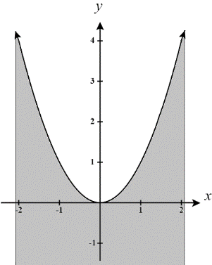
We see that in order for this function to be defined. Therefore, we define the domain as: . A picture of this domain is shown below (note this domain continues to extend to the left, right, and downwards.

The range of this function is since we can make equal to zero and as large as we wish.

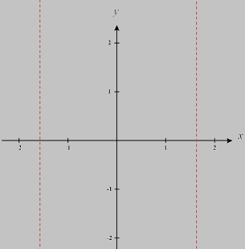
We see that is must be true that , where k is an integer, in order for this function to be defined. Therefore, we define the domain as: . A picture of this domain is shown below (note this domain continues to extend to the left and right and always excludes all points on the , where k is an integer.
The range of this function is .

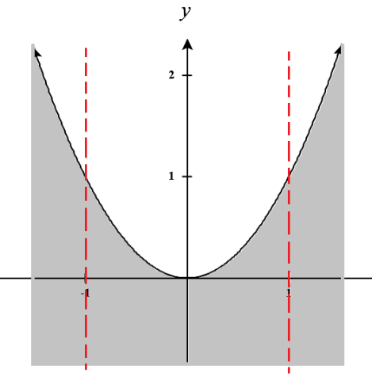
We see that and in order for this function to be defined. Therefore, we define the domain as: . A picture of this domain is shown below (note this domain continues to extend to the left, right, and downwards.

The range of this function is since we can make equal to zero and as large as we wish.

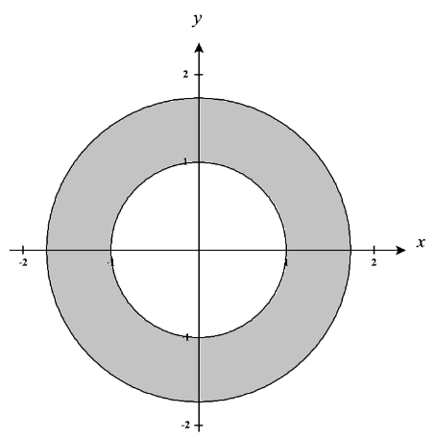
We see that in order for this function to be defined. Therefore, we define the domain as: . A picture of this domain is shown below.
The range of this function is as this is the standard range the inverse sine function and we can make equal to any value between and 1.

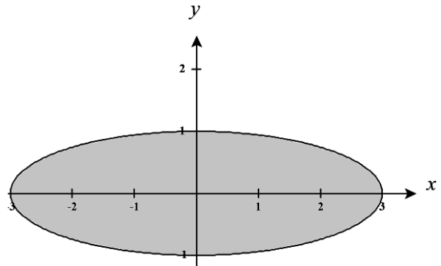
We see that in order for this function to be defined. Therefore, we define the domain as: . A picture of this domain is shown below

The range of this function is since we can make as close to 0 as we would like, but we can’t increase this expression past the value of 9.

- For each function, label its graph from among the options below by writing the corresponding letter in the box next to the graph.
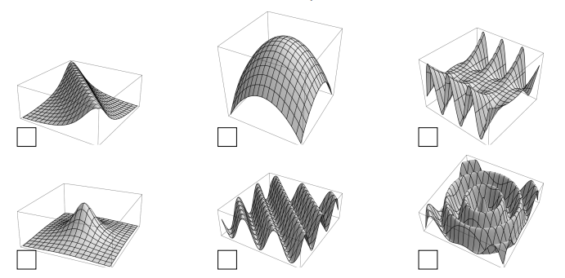
(A) (B)

- If we fix y as a constant the equation should produce sine waves. If we fix x as a constant the equation should produce parabolas. Therefore, we select the top right option.
- We see that for values of x and y that are far from 0 the z-value of the graph should be very small. The z-value of the graph should increase as x and y approach zero and peak at with . Therefore, we select the bottom left option.

- For each graph below, find the corresponding function from the options at the right and write the corresponding letter in the box next to the graph.
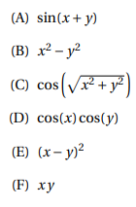
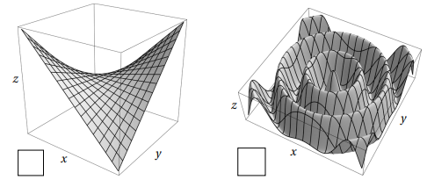

For the first graph we see that along the lines and the graph has the behavior of a parabola (one opening up and the other down). The only options that could account for this behavior are (B), (E), and (F). We see that if we fix x or y as a constant the graph shows line like behavior. This leads us to the conclusion that (F) is the best option for this graph.

For the second graph we have wave like behavior and so we immediately consider options (A), (C), and (D). We notice that there is also a circular pattern to the “waves” within the graph. This circle behavior is accounted for by in (C). This leads us to the conclusion that (C) is the best option for this graph.
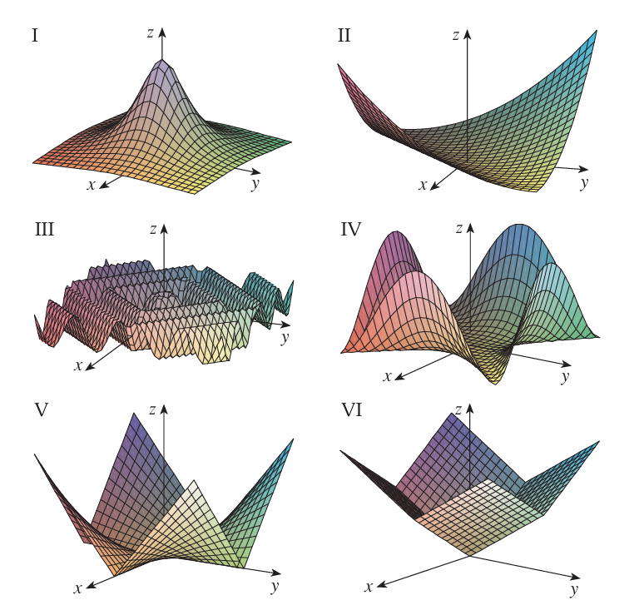
- Match the function with its graph.

If we fix x or y we have an absolute value function. This corresponds VI.

If we fix x or y we have an absolute value function. If we let or then we get . This corresponds V.

We see that as x and y increase the value of z should approach 0. For values of x and y close to 0 we should find z is closer and closer to 1. When then .
This corresponds to I.

If we fix x or y we should see upward facing parabola-like quartic functions.
If we let or we have that .
This corresponds to IV.

If we fix x or y we should see upward facing parabolas.
If we let we have that .
This corresponds to II.

If we fix x or y we should see a sine curve.
If we let or then we get something like , but this is again a sine curve but with a shorten period.
This corresponds to III.

- Match the following functions with their graphs and level set diagrams.
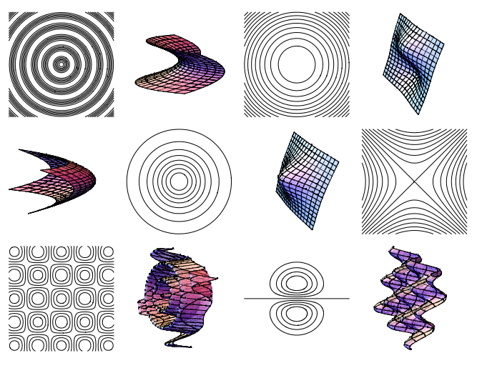

- We can see that if x is constant then our equation produces cosine waves. If y is constant, then our equation produces sine waves. Therefore, we select the bottom left option for the picture of the graph and the top left for its level sets.
- If x or y is constant, then our equation produces parabolas. If z is constant, then our equation produces circles of varying radii. Therefore, we select the top middle option for the picture of the graph and the 3rd row right option for its level sets.
- If x or y is constant, then our equation produces parabolas. If z is constant, then our equation produces hyperbolas. Therefore, we select the 2nd row right option for the picture of the graph and the bottom row middle option for its level sets.

- Match the function with its graph and with its contour map.
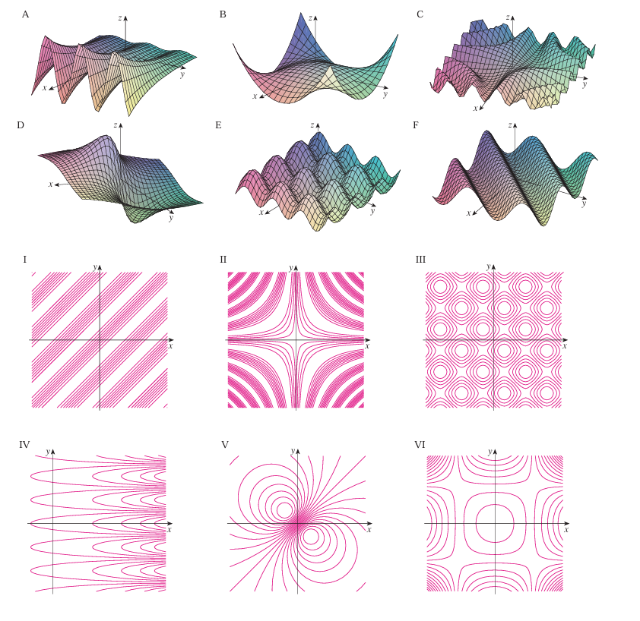
- If we fix x or y we have sine function. The larger either of these values are the smaller the period of the sine wave becomes. This corresponds to surface C which has contour map II.
- If we fix x we have a cosine graph. If we fix y we have an exponential graph. Note then as x approaches negative infinity the value of z should approach 0. As x approaches positive infinity the value of z should approach (based on the sign of ). This corresponds to surface A which has contour map IV.
- If we fix x or y we have a shifted sine graph. If then we have . This corresponds to the surface F which has a contour map I.
- If you fix x or y you have vertically shifted sine graph. We note that these sine curves has a consistent period and run parallel to the x and y axes. If you let , then you get . This corresponds. This corresponds to surface E which has contour map III.
- If you fix x or y you should see downward facing parabolas. If you let or , then . We note that as x and y both increase toward , z will always increase towards . This corresponds to surface B which has a contour map VI.
- If you let , then . For large values of x and y out in any quadrant we note that the denominator of the function will become very large and thus we should see z approach 0 in all directions. This corresponds to surface D which has contour map V.

